PROJECT REPORT TEMPLATE

**INTRODUCTION:**

* **OVERVIEW:**

The Tableau HR Scorecard is a framework designed to measure and evaluate the success of talent management strategies within an organization. It provides a way for HR professionals and business leaders to track and analyze key performance indicators (KPIs) related to workforce planning, recruitment, retention, and development.

* **PURPOSE:**

The problem is to develop effective Data Visualization strategies which is crucial to measure and interpret the success of talent management from HR perspective.

**PROBLEM DEFINITION AND DESING THINKING:**

* **2.1: EMPATHY MAP:**

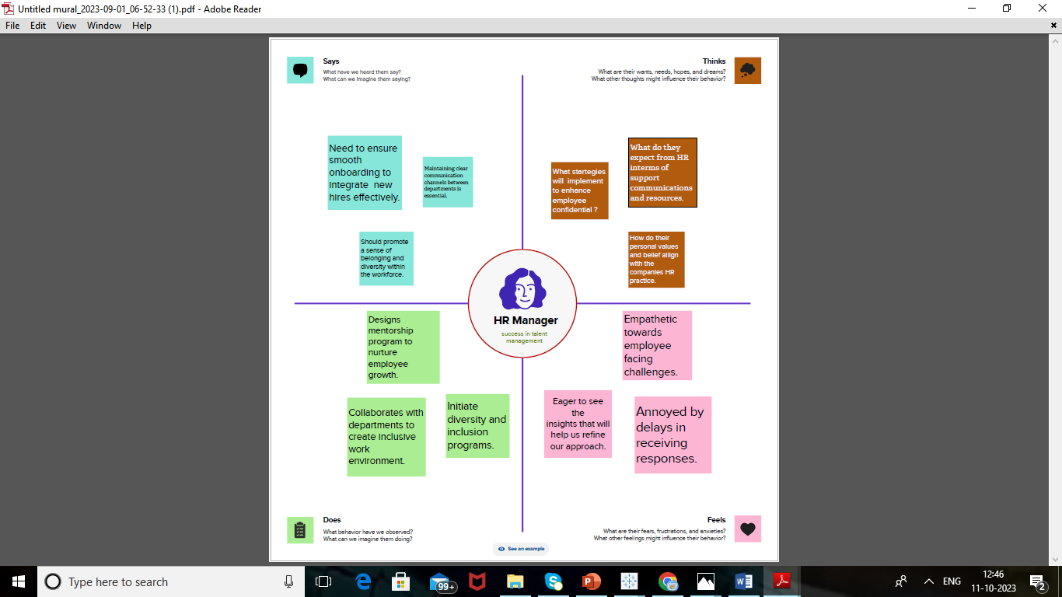

* **2.2: IDEATION AND BRAINSTORMING:**

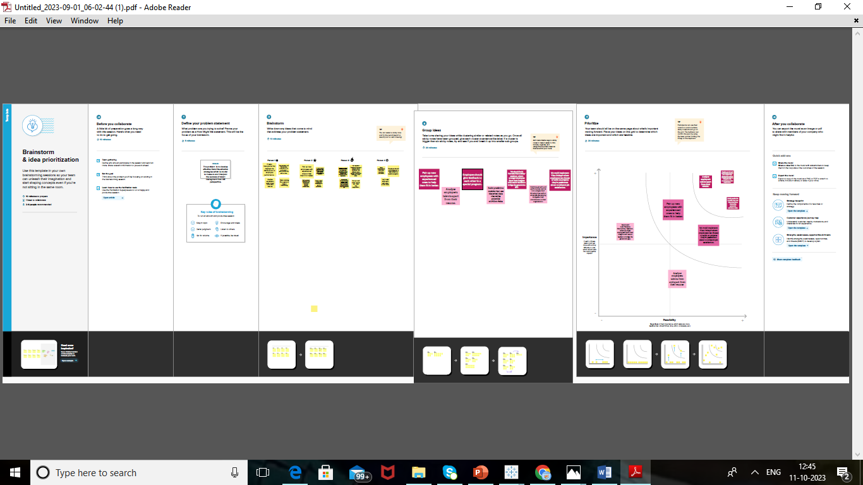

**RESULTS:**

* **3.1: DASHBOARD:**

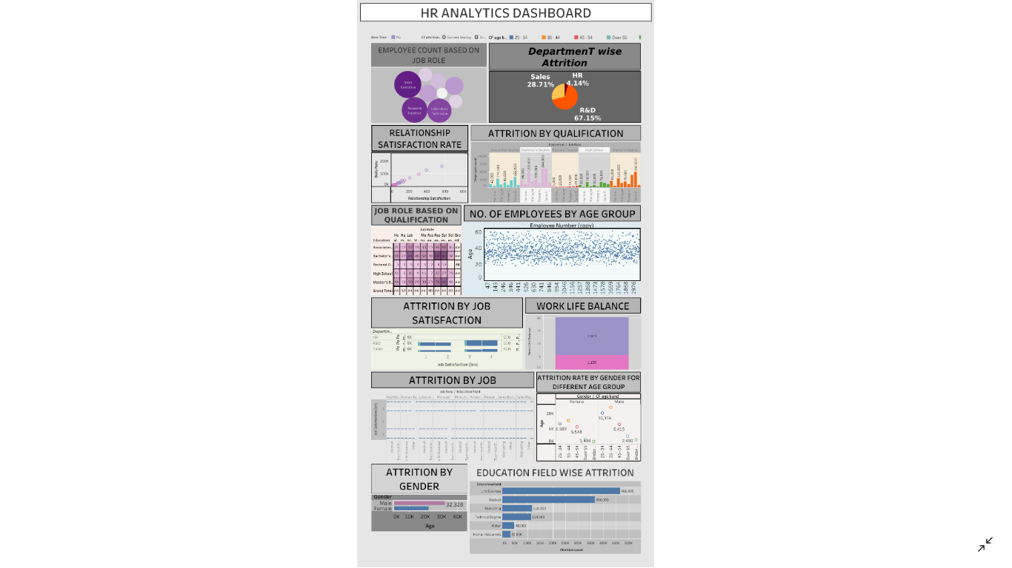

* **3.2: STORY:**

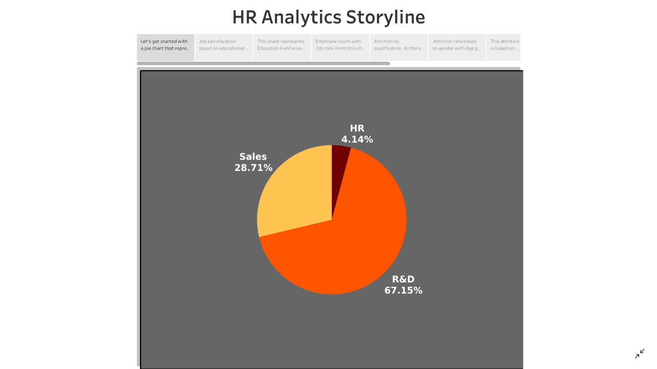

**ADVANTAGES AND DISADAVANTAGES :**

* **4.1: ADVANTAGES:**

1. Visualization simplifies complex data, making it easier for HR to understand performance metrics related to talent management.
2. Visual representations helps HR in quick identification of trends and areas that require attention to make decisions promptly.
3. From bubble chart it’s easy for us to understand the employee count based on their job role.
4. HR scorecards facilitate benchmarking against industry standards and competitors, helping organizations gauge their relative performance.
5. Stacked bars helps us to visualize the attrition by qualification.

* 4.2: DISADVANTAGES:

1. Making HR scorecard visualizations can be hard and time consuming.
2. If the data collected to make HR scorecard is not accurate, the scorecard won’t be useful and may lead to confusion.
3. The choice of which metrics to visualize can be subjective, potentially leading to bias in the reporting and interpretation of talent management success.
4. If the collected data is not updated manually that may cause loss to employees.
5. HR scorecard data doesn’t support Geographical visualization even when calculation and filters are applied.

APPLICATIONS:

Visual scorecards can provide a quick overview of recruitment metrics, such as time-to-fill, cost-per-hire, and quality-of-hire, helping HR professionals make data-driven decisions in the hiring process .Visual scorecards can display employee performance metrics, making it easier to assess individual and team performance and identify opportunities for development. Visualizing engagement survey results and related data can help HR identify trends, measure the impact of engagement initiatives, and take actions to improve workplace satisfaction.

CONCLUSION:

A well-designed HR scorecard provides a data-driven approach to talent management. It allows us to base their decisions on objective insights and empirical evidence, reducing the reliance on intuition or guesswork. The HR scorecard isn't just a static tool; it's a dynamic one that evolves over time. Regularly updating and analyzing the scorecard helps us identify areas for improvement and make necessary adjustments to talent management strategies .Visualizations save time and effort by presenting data in a concise, digestible format, streamlining the monitoring and reporting process.

FUTURE SCOPE:

1. The future will likely see a shift towards real-time data visualization, allowing HR professionals to monitor talent metrics and make immediate adjustments. This will be crucial in rapidly changing business environments.
2. HR scorecards will become more accessible on mobile devices, enabling HR professionals and stakeholders to access critical talent data on the go, enhancing flexibility and responsiveness.
3. Interactive data visualization tools will become more common, allowing users to explore HR data dynamically and gain deeper insights through self-service analytics.
4. HR scorecards may incorporate ESG metrics to measure an organization's impact on society and the environment, aligning talent management with broader corporate responsibility.
5. Visual HR scorecards will continue to allow organizations to benchmark their talent management performance against industry standards and peers, aiding in competitiveness and innovation.